(Front Page)
Sadie Elizabeth Collins
30/12/09 – 10/09/10
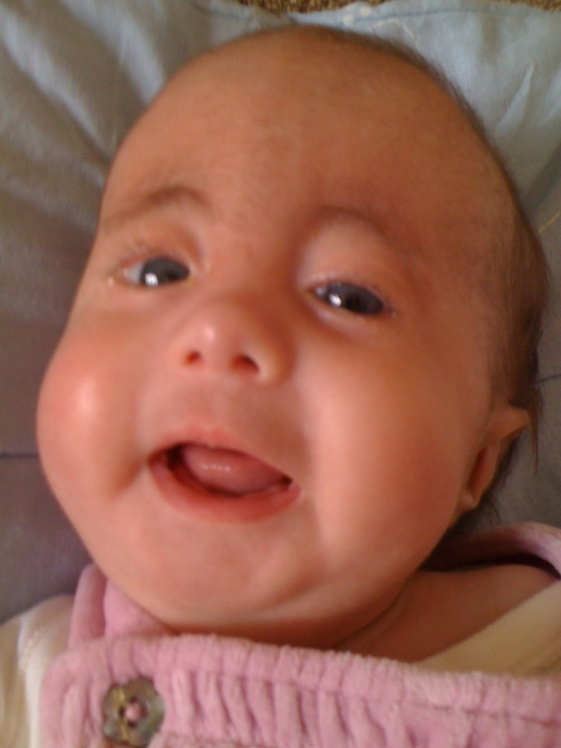

(Inside page 1)
The Cord
We are connected , My child and I
by an invisible cord, not seen by the eye
It's not like the cord that connects us til birth
this cord can't be seen by any on earth
This cord does it's work right from the start
it binds us together attached by my heart
I know that it's there , though no one can see
the invisible cord from my child to me
the strength of this cord is hard to describe
it can't be destroyed , it can't be denied
it's stronger than any cord man can create
it withstands the tests , can hold any weight
and though you are gone, though you’re not here with me
the cord is still there , but no one can see
It pulls at my heart, I am bruised, I am sore
But this cord is my lifeline as never before
I am thankful that God connects us this way
A parent and child, death can't take this away
Anon

(Inside Page 2)
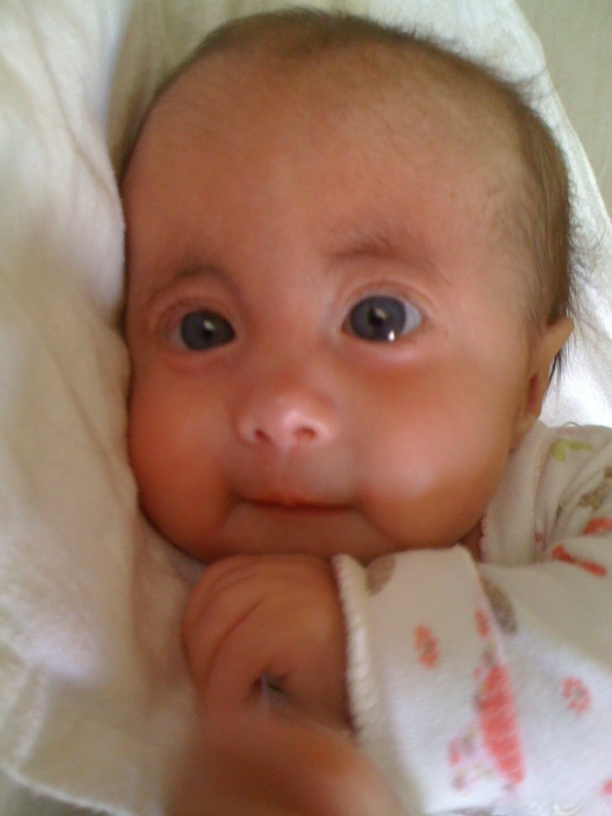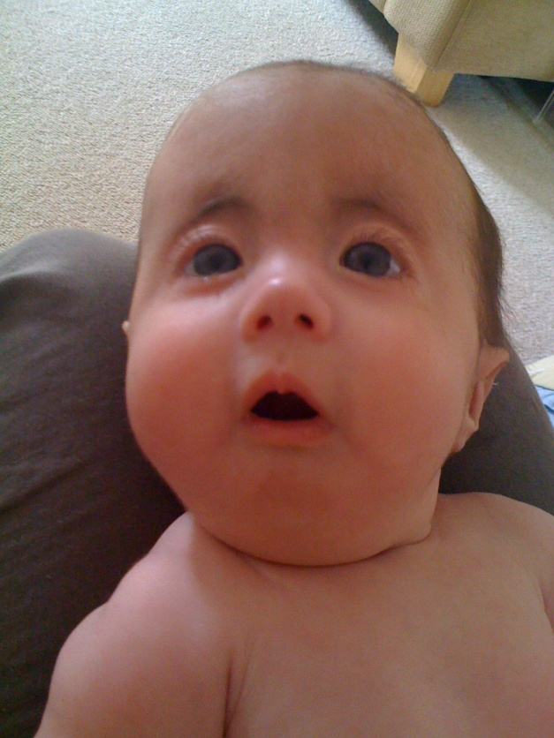

(Back Page)
We would like to thank...
Our family and friends for their love and support
All the staff and doctors of Francis House Children’s Hospice
Special Care Baby Unit team at Macclesfield Hospital
All the medical and healthcare professionals who helped Sadie
St Wilfrid’s Church, Mobberley and Knutsford Methodist Church
Everyone who prayed for and loved Sadie

